**Java AWT Label**

The object of the Label class is a component for placing text in a container. It is used to display a single line of **read only text**. The text can be changed by a programmer but a user cannot edit it directly.

It is called a passive control as it does not create any event when it is accessed. To create a label, we need to create the object of **Label** class

**AWT Label Class Declaration**

**public class** Label **extends** Component **implements** Accessible

**AWT Label Fields**

The java.awt.Component class has following fields:

1. **static int LEFT**: It specifies that the label should be left justified.
2. **static int RIGHT**: It specifies that the label should be right justified.
3. **static int CENTER**: It specifies that the label should be placed in center.

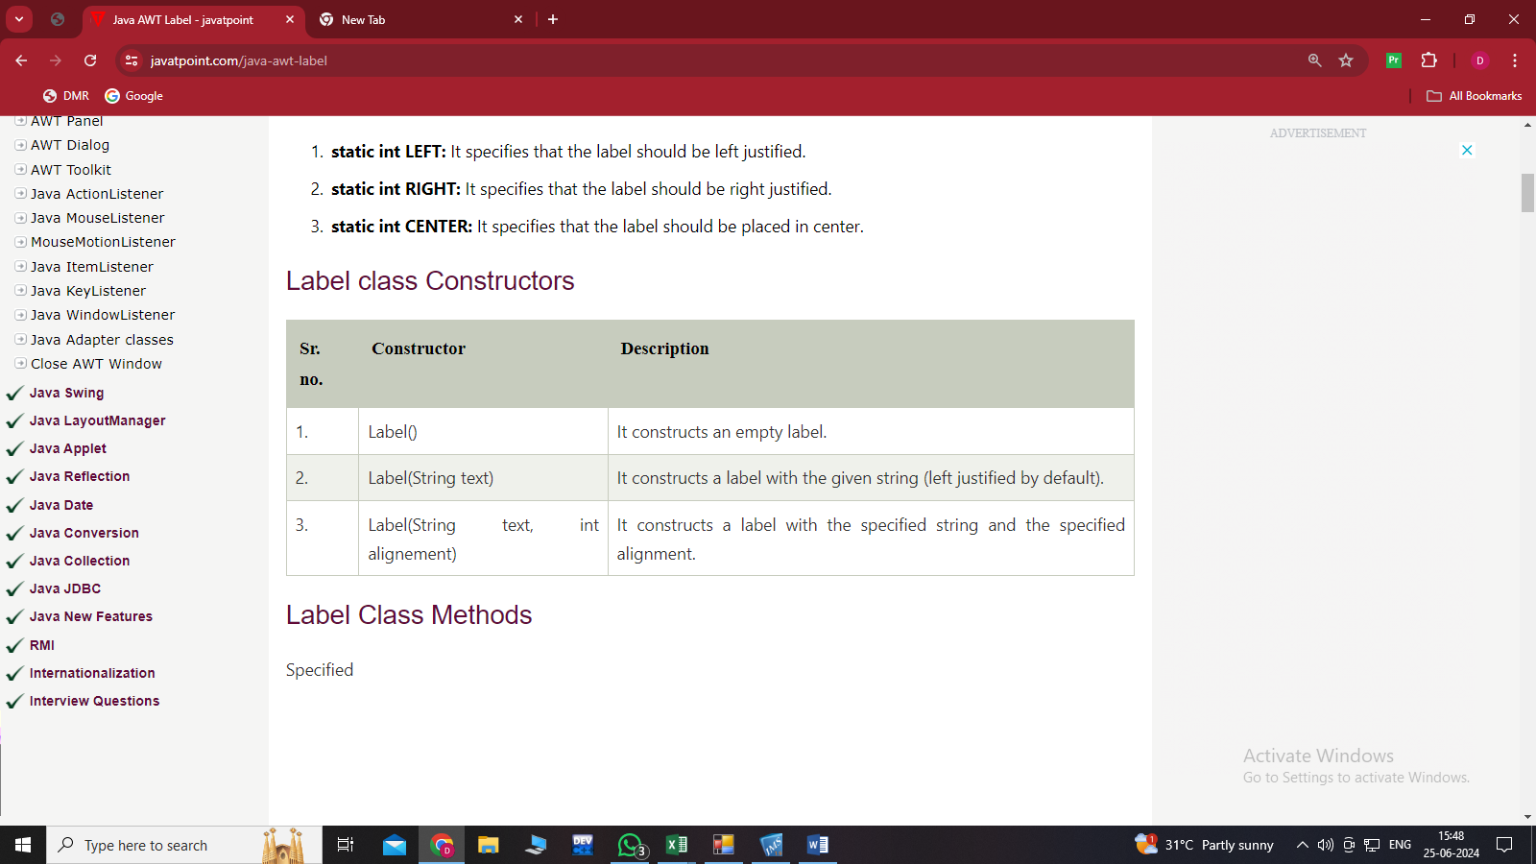**Label class Constructors**

**Label Class Methods**

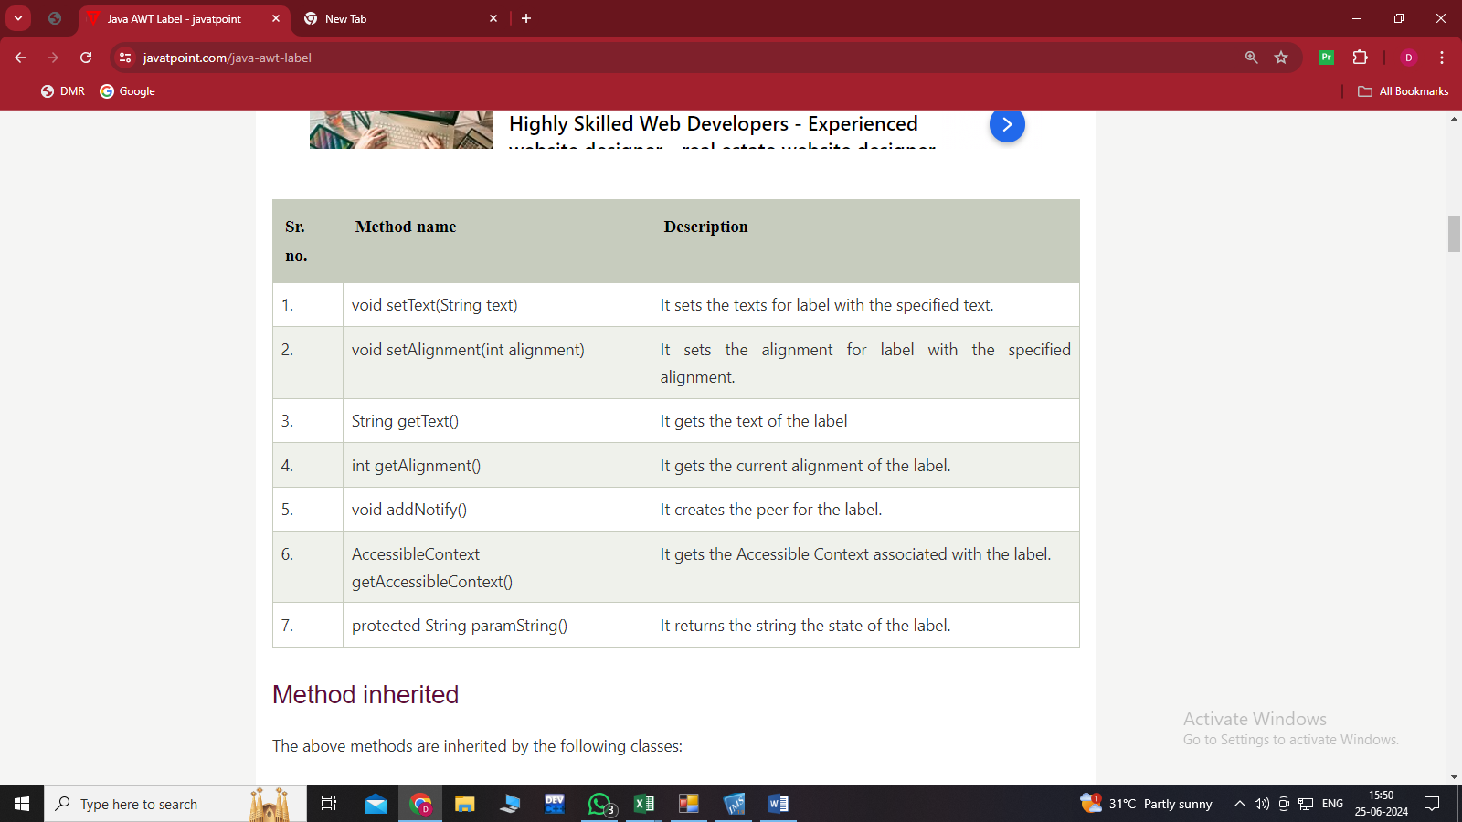

**Method inherited**

The above methods are inherited by the following classes:

1. java.awt.Component
2. java.lang.Object

**Java AWT Label Example**

In the following example, we are creating two labels l1 and l2 using the Label(String text) constructor and adding them into the frame.

**LabelExample.java**

import java.awt.*;

public class LabelExample

{

public static void main(String args[])

{

// creating the object of Frame class and Label class

Frame f = new Frame ("Label example");

Label l1, l2;

l1 = new Label ("First Label.");

l2 = new Label ("Second Label.");

// set the location of label

l1.setBounds(50, 100, 100, 30);

l2.setBounds(50, 150, 100, 30);

// adding labels to the frame

f.add(l1);

f.add(l2);

// setting size, layout and visibility of frame

f.setSize(400,400);

f.setLayout(null);

f.setVisible(true);

}

}

**Java AWT Label Example with ActionListener**

In the following example, we are creating the objects of TextField, Label and Button classes and adding them to the Frame. Using the actionPerformed() method an event is generated over the button. When we add the website in the text field and click on the button, we get the IP address of website.

**LabelExample2.java**

import java.awt.*;

import java.awt.event.*;

// creating class which implements ActionListener interface and inherits Frame class

public class LabelExample2 extends Frame implements ActionListener

{

// creating objects of TextField, Label and Button class

TextField tf;

Label l;

Button b;

// constructor to instantiate the above objects

LabelExample2()

{

tf = new TextField();

tf.setBounds(50, 50, 150, 20);

l = new Label();

l.setBounds(50, 100, 250, 20);

b = new Button("Find IP");

b.setBounds(50,150,60,30);

b.addActionListener(this);

add(b);

add(tf);

add(l);

setSize(400,400);

setLayout(null);

setVisible(true);

}

// defining actionPerformed method to generate an event

public void actionPerformed(ActionEvent e)

{

try {

String host = tf.getText();

String ip = java.net.InetAddress.getByName(host).getHostAddress();

l.setText("IP of "+host+" is: "+ip);

}

catch (Exception ex)

{

System.out.println(ex);

}

}

public static void main(String[] args)

{

new LabelExample2();

}

}